**Day 7 Notes**

**Astrid and Gear**



Example Circuit

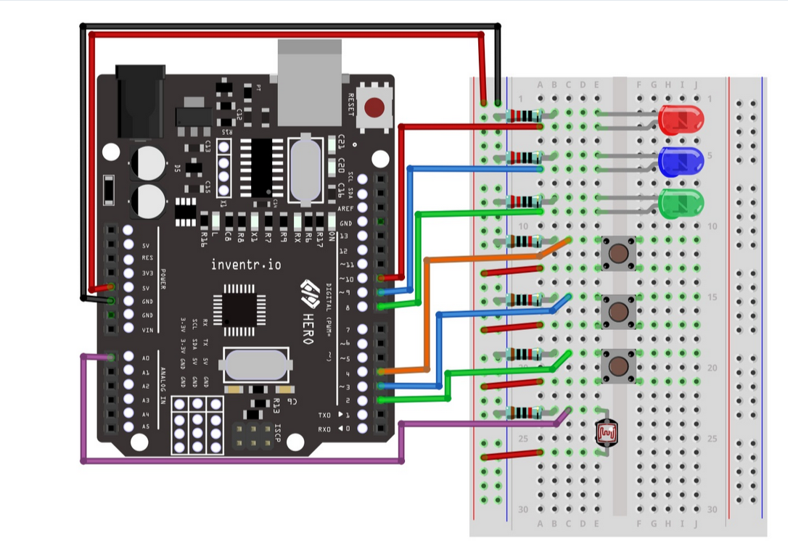

220Ω Resister for LED

10KΩ Resistor for Photoresistor

My Circuit

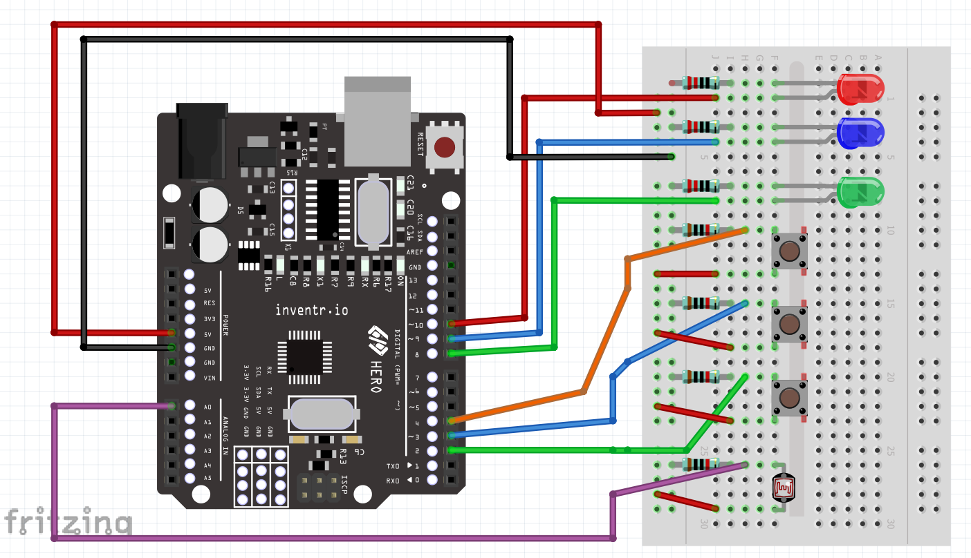

A0 – Photoresistor

2 – Green Button

3 – Blue Button

4 – Orange / Red Button

8 – Green LED

9 – Blue LED

10 – Red LED

Notes:

Looks like it is working, confirm the intended function of the following code:

ledBrightness = map(sensorValue, 0, 1023, 0, 255);

Map:

0 -1023 read from analog pin.

Mapped to

0 - 255 that PWM (pulse width modulation) on LED Pins can accommodate.







The Green LED Does not change brightness because it is mapped to Pin 8 which is not a PWM Pin.

Rewire to Pin 6, Adjust Code to match and compare function.

